# Migrating Jenkins Environments to Jenkins 2

**Revision 1.6 - 11/04/17**

**Brent Laster**

**IMPORTANT NOTES:**

**1. You must have internet access through your VM for some of the labs.**

**2. If you run into problems, double-check your typing!**

**3. When the system tells you to save a file you’ve been working on in the editor (such as gedit), you will also need to exit the editor unless you started it running in the background.**

**Lab 1 starts on the next page!**

**Lab 1 - Creating a Simple Pipeline Script**

**Purpose: In this first lab, we’ll start with a sample pipeline script and change it to work for our setup to illustrate some basic pipeline concepts.**

1. Start Jenkins by clicking on the “**Jenkins 2**” shortcut on the desktop OR opening the Firefox browser and navigating to “**http://localhost:8080**”.

2. You should be on the login screen. Log in to Jenkins with User = **jenkins2** and Password = **jenkins2**

(**Note: If at some point during the workshop you try to do something in Jenkins and find that you can’t, check to see if you’ve been logged out. Log back in if needed**.)

3. Click on the “**Manage Jenkins**” link in the menu on the left-hand side. Next, look in the list of selections in the lower section of the screen, and find and click on “**Manage Nodes**”.

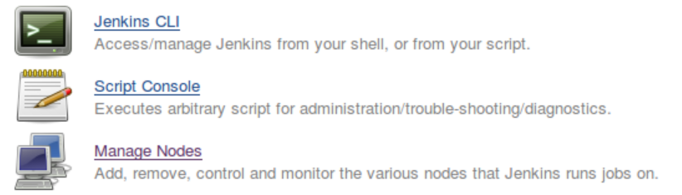

4. On the next screen, notice that you already have nodes (formerly known as slaves) named “worker_node1”, “workder_node2”, and “worker_node3”. We’ll use these to run our processes on. Note that you wouldn’t normally have a node defined on the same system as the master, but we are using this setup to simplify things for the workshop.

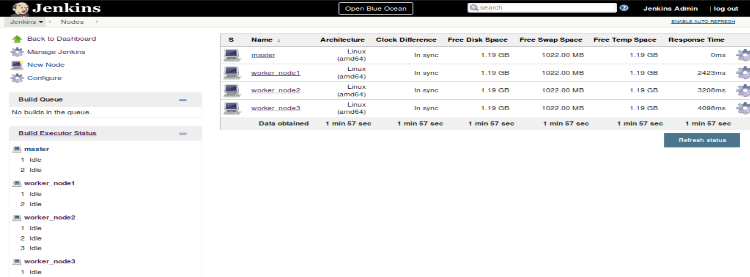

5. Click on “**Back to Dashboard**” (upper left) to get back to the Jenkins Dashboard. Now we’ll create our first pipeline project. In the left column, click on “**New Item**”. Notice that there are quite a few different types of items that we can select here. Type a name into the “**Enter an item name**” field. As a suggestion, you can use “**simple-pipe**”. Then choose the “**Pipeline**” project type and click on the “**OK**” button to create the new project.

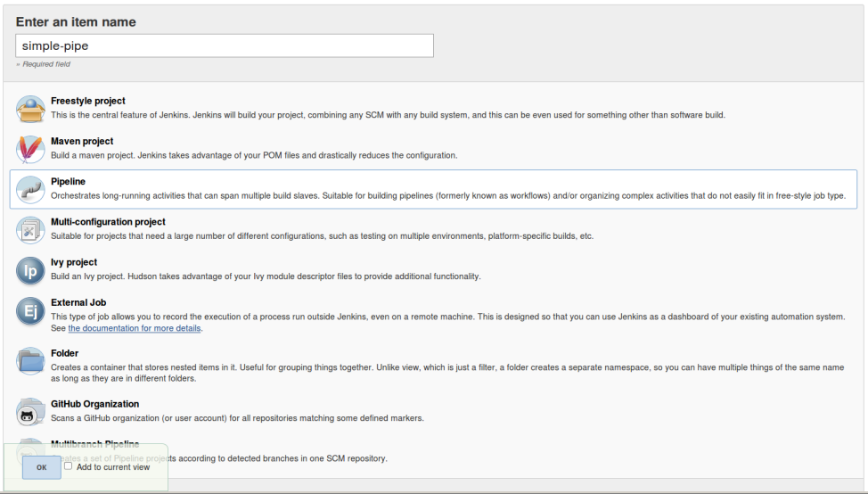

6. Once Jenkins finishes loading the page for our new item, scroll down and find the **Pipeline** section. Leave the **Definition** selection as “**Pipeline script**”. Now, we’ll create a simple script to pull down a Git repository already installed on the image. We’ll create a **node** block to have it run on “**worker_node1**”, and then a **stage** block within that to do the actual source management command. The Pipeline DSL here provides a “**git**” command that we can leverage for that.

Inside the input area for the **Script** section, type (or paste) the code below. (You can leave out the comments if you prefer.)

**node ('worker_node1') {**

**stage('Source') { // for display purposes**

**// Get some code from our Git repository**

**git 'git@diyvb2:/opt/git/gradle-demo.git'**

**}**

**}**

This is what it will look like afterwards.

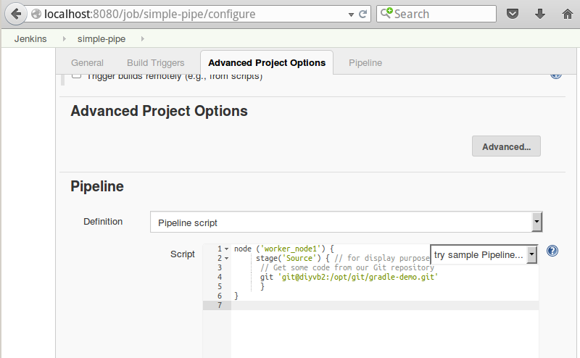

Now, click the **Save** button to save your changes.

7. You’ll now be on the job view for your new job. Notice the reference to the “**Stage View**”. Since we haven’t run the job yet, there’s nothing to show here, as the message indicates.

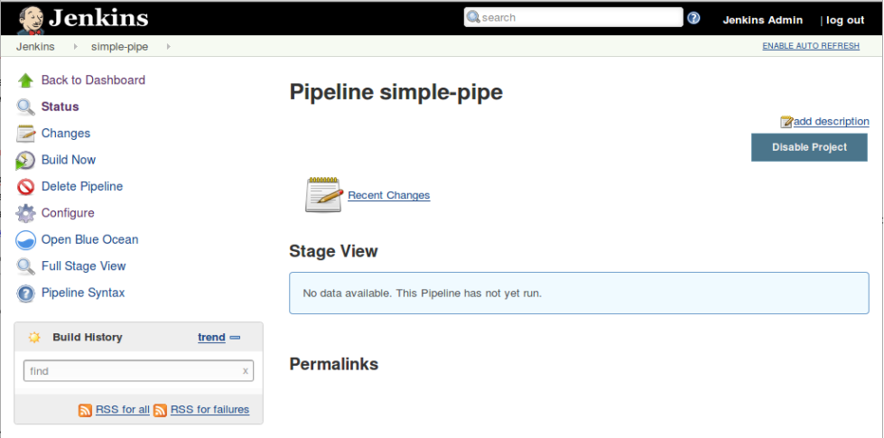

8. Click on the “**Build Now**” link to build your job. (It may take a moment to startup and run.) After it runs, notice that you now see a **Stage View** that is more informative. The “**Source**” name is what we had in our stage definition. We also have the time the stage took and the green block indicating success.

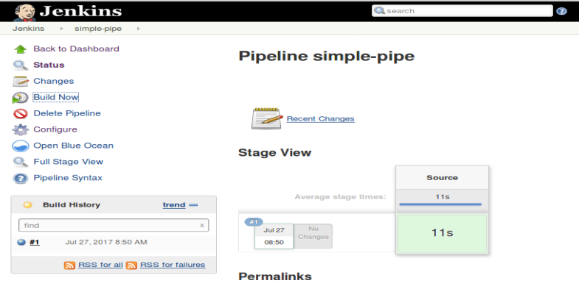

9. Let’s look at the logs for this stage via this page. Hover over the green box for the **Source** stage until you see another box pop up with a smaller box named “**Logs**”.

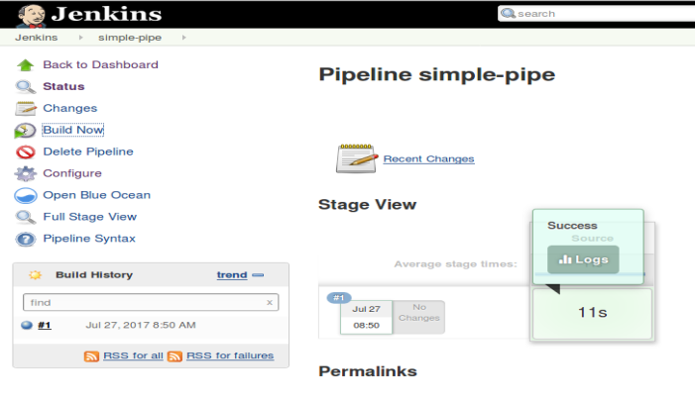

10. Now, click on that smaller “**Logs**” box inside the “**Success**” box to see the log for the run of the stage pop up.

(Of course, you could also use the traditional Console Output route to see the logs.)

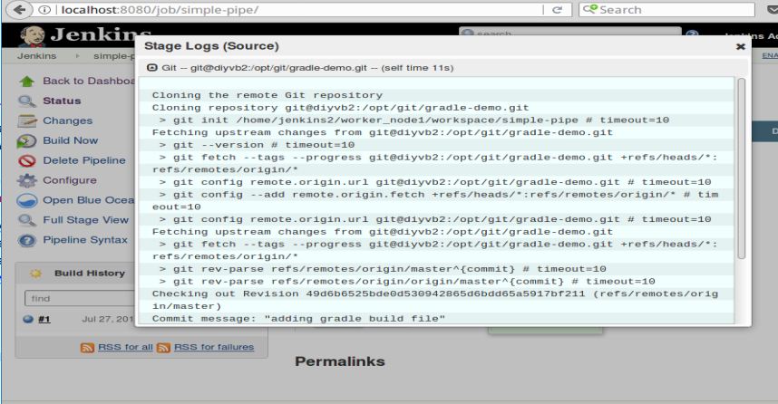

11. Close the popup window for the logs and click on **Back to Dashboard** to be ready for the next lab.

**=============================================================================================**

**END OF LAB**

**=============================================================================================**

**Lab 2 - Adding a Build Stage**

**Purpose: In this lab, we’ll add a new stage to our pipeline project to build the code we download. We’ll also see how to use the Replay functionality and include tools defined globally in Jenkins.**

1. For this lab, we’ll add a stage to use Gradle to build our **gradle-demo** project. We already have Gradle installed and configured on this Jenkins instance. So we just need to understand how to reference it in our pipeline script.

2. You should be back on the **Jenkins Dashboard** (home page) after the last lab. To see the Gradle configuration, click on **Manage Jenkins** and then select **Global Tool Configuration** in the list.

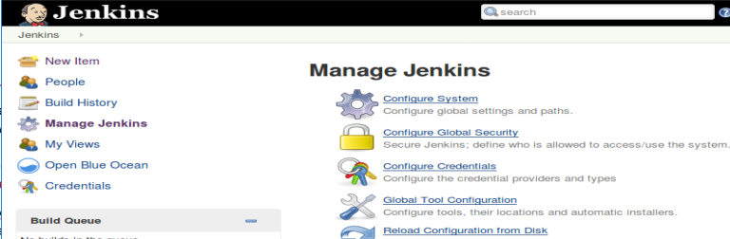

3. On the **Global Tool Configurations** page, scroll down and find the **Gradle** section. Click on the “**Gradle Installations**” button. Notice that we have our local Gradle instance named as “gradle32” here. We’ll need to use that name in our pipeline script to refer to it.

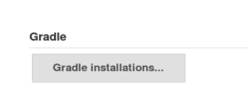 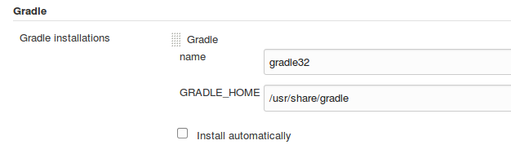

4. Switch back to the configuration for your **simple-pipe** job - either by going to the Dashboard, then selecting the job, and then selecting **Configure** or just entering the URL: **http://localhost:8080/view/All/job/simple-pipe/configure .**

5. Scroll down to the pipeline script input area again and add the lines in bold below (continued on next page) to your job. This sets us up to use the Gradle tool that we have installed. (Notice that the closing brace for the node has to come after the Build stage definition.)

node ('worker_node1') {

**def gradleHome**

stage('Source') { // for display purposes

// Get some code from our Git repository

git ‘git@diyvb2:/opt/git/gradle-demo.git’

}

**stage('Build') {**

**// Run the gradle build**

**gradleHome = tool 'gradle32'**

**}**

}

6. Now that we have the stage and have told Jenkins how to find the gradle installation that we want to use, we just need to add the command to actually run gradle and do the build. That command is effectively just **gradle** followed by a list of tasks to run.

We’ll use a shell command to run this. The **gradleHome** value we have is what’s configured for that value - the home path for Gradle. To get to the executable, we’ll need to add on “**bin/gradle**”. Then we’ll add in the gradle tasks that we want to run. To make this all work, add in the line in bold below in the **Build** stage. Note the use of the single quotes and the double quotes. (There is a double quote and then a single quote before ${gradleHome … )

stage('Build') {

// Run the gradle build

gradleHome = tool 'gradle32'

**sh "'${gradleHome}/bin/gradle' clean buildAll"**

}

7. Now, **Save** your changes and click on the “**Build Now**” link in the left column. Wait for the run to complete. (This will take a while for the gradle part.) Notice the **Stage View** now, and the color of the boxes. The “pink” indicates a successful stage in an overall failure. The pink and red stripe indicates a failures (as does the “failed” note in the bottom right corner).

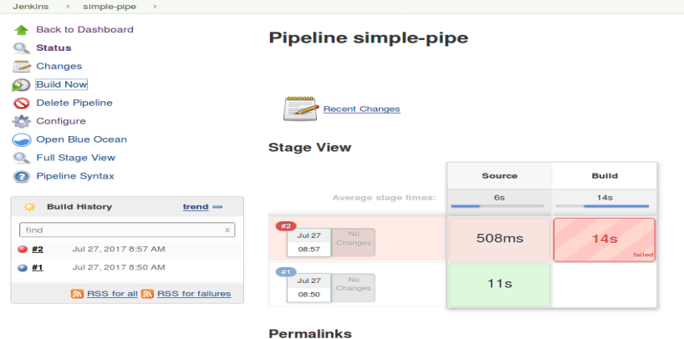

8. Hover over each box for the stages in the most recent run (#2) to see the status information for that stage.

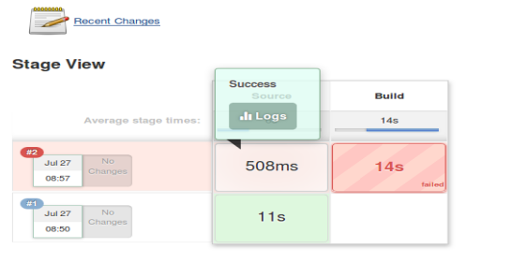 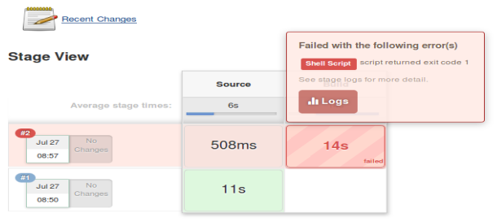

9. While hovering over the **Build** stage box, notice the message telling you which step failed (“**Shell Script**”). Click on the **Logs** link to bring those up. In the pop-up box, you’ll see a description of the steps involved in this stage. Click on the small down arrow in the square next to “**Shell Script**” to expand the log information. What is the error message?

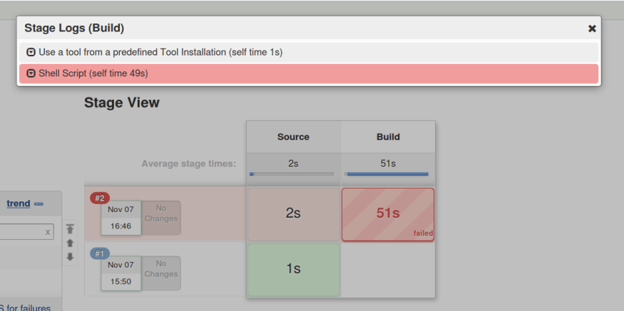 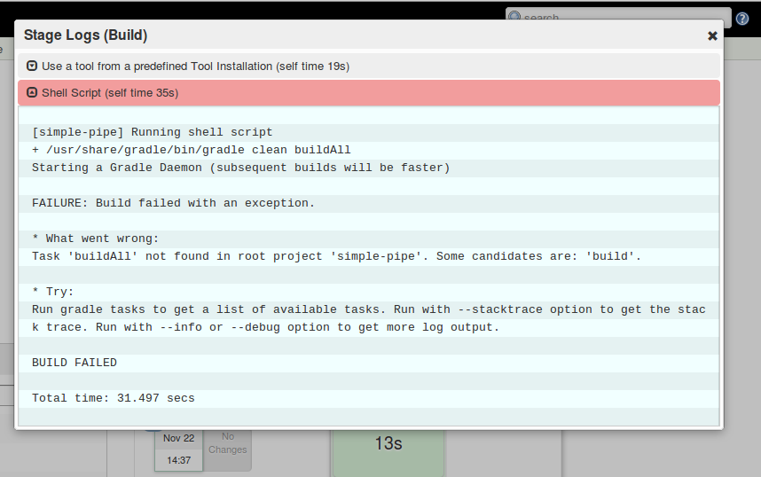

10. The log shows the problem - there is not a “**buildAll**” task. The reason is that, for Gradle, the task should be “**build**”. Let’s fix that. Use the escape key or X in the corner to close the **Stage Logs (Build)** window.

11. Before we change our script though, let’s use the **Replay** functionality to test this change out. To use this, we’ll need to get to the screen for the specific build that failed. In the “**Build History**” window, click on the red ball next to the latest build, or click on the “**Last build (#2)**” link in the **Permalinks** section.

12. In the left column, click on the **Replay** menu item. After a moment, the replay screen will appear with a copy of the pipeline script as it is for this build.

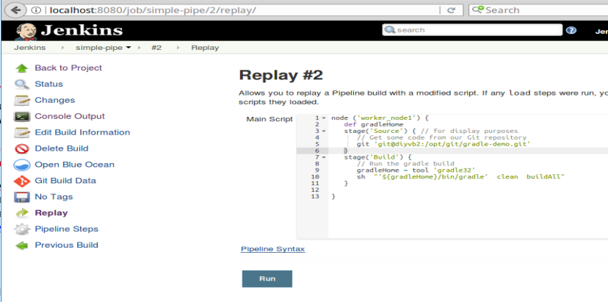

13. On the line that has the gradle command and the “**buildAll**” task, change “**buildAll**” to just “**build**”. Then click the “**Run**” button. Notice that this kicks off another build, which should complete successfully after a few moments.

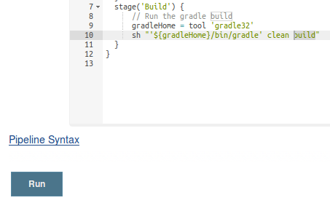 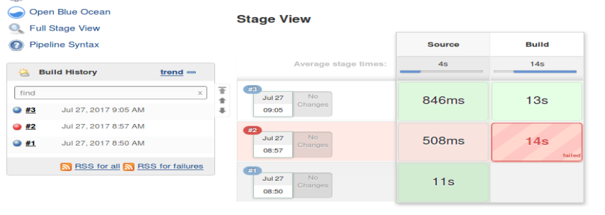

14. Click on the **Configure** menu item on the left. Scroll down to the **Pipeline** section and look at the code in the **Pipeline script** window. Notice that it still has the old code in it (“**buildAll**”). The **Replay** allowed us to try something out without changing the code.

Edit the same line in this window as in the previous step to change “**buildAll**” to just “**build**”. **Save** your changes and then **Build Now** (left menu). This build (#4) should complete successfully after a few moments.

**=============================================================================================**

**END OF LAB**

**=============================================================================================**

**Lab 3 - Using Shared Libraries**

**Purpose: In this lab, we’ll replace our use of the build command with code defined in a shared library.**

1. For the workshop, we have defined some shared libraries and functions in a “shared-libraries” Git repository. We have one named “Utilities” that we’ll use to replace our build step here. You can see the definition of it in the directory **~/shared-libraries/src/org/conf/Utilities.groovy**. It takes a reference to our script and build arguments to pass to our gradle instance for a build.

package org.foo

class Utilities {

static def gbuild(script, args) {

script.sh "${script.tool 'gradle32'}/bin/gradle ${args}"

}

}

2. To make this available to our pipeline scripts, we need to add it into our Jenkins system configuration. From the dashboard, click on **Manage Jenkins**, then **Configure System**.

3. Scroll down until you find the “**Global Pipeline Libraries**” section. Click the “**Add**” button.

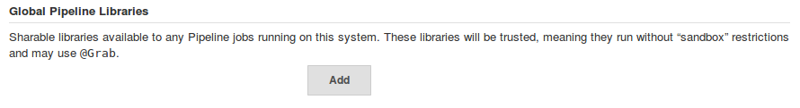

4. Fill in the general fields in this section as follows:

For **Name**, enter “**Utilities**”. This will be the name you refer to the library by in the script.

For **Default version**, enter a tagged version. In this case, the latest version is “**1.5**”, so enter that. Note that while a branch name can be used here, updates to that may not be picked up over time.

Leave the **“Load implicitly”** checkbox unchecked. Loading a library implicitly is a convenience, but we don’t want to have it loaded for every project we create.

Leave the “**Allow default version to be overridden**” box checked to tell Jenkins to allow loading a different version of this library in your script if you specify the version in conjunction with the @Library directive. (i.e. @Library(‘libname@version’))

You can leave “ **Include @Library changes in job recent changes**” checked as well.

For **Retrieval method**, select **Modern SCM**. This is allowing pulling the library from source control via the Git plugin that has been updated for pipeline.

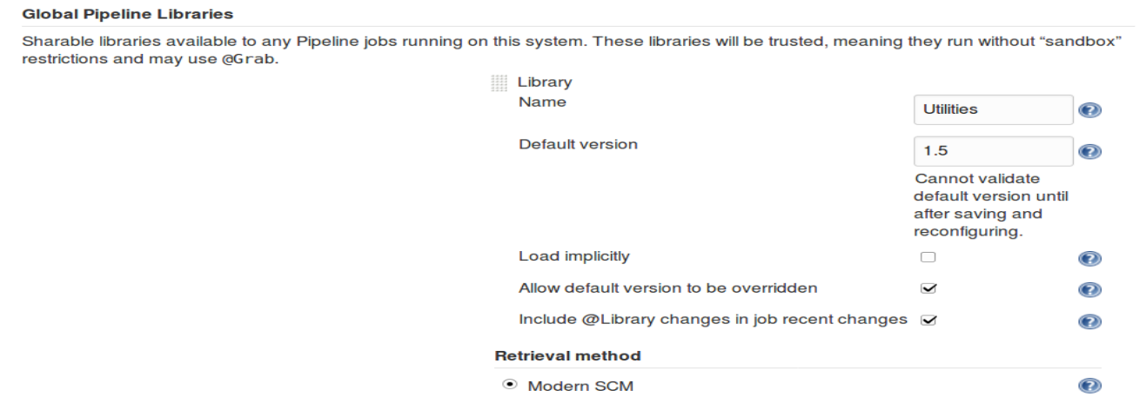

5. We’ll use **Git** as our **Source Code Management** system to include the library since it is stored in a Git repository. So we’ll need to select Git in that section and configure it to point to that repository.

After selecting **Git,** enter [git@diyvb2:/opt/git/shared-libraries.git](mailto:git@diyvb2:/opt/git/shared-libraries.git) in the **Project Repository** field.

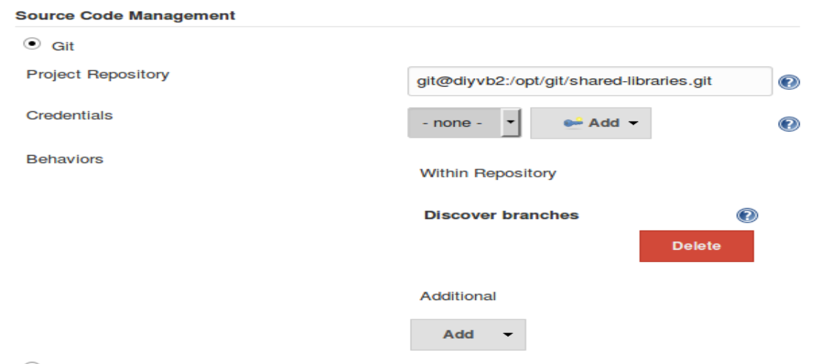

6. **Save** your changes to the system configuration.

7. Now, go back to your **simple-pipe** job and select the **Configure** item. Modify the pipeline script in your job to load the shared library, import the method from our library, and use the new call to build the code. (See listing below.) Afterwards, your pipeline script should look like below - note the added/changed lines in bold. The gbuild line replaces the previous gradle line. (Lines referencing gradleHome are no longer needed and can be removed.)

**@Library('Utilities@1.5')**

**import static org.conf.Utilities.\***

node ('worker_node1') {

stage('Source') { // for display purposes

// Get some code from our Git repository

git ‘git@diyvb2:/opt/git/gradle-demo.git’

}

stage('Build') {

// Run the gradle build

**gbuild this, 'clean build'**

}

}

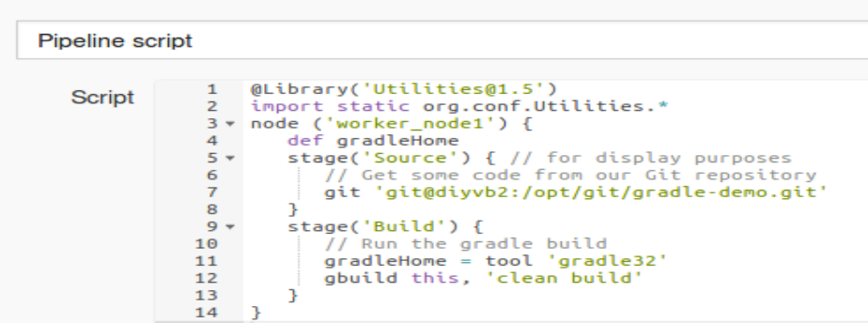

8. **Save** your changes and **Build Now**.

**=============================================================================================**

**END OF LAB**

**=============================================================================================**

**Lab 4 - Loading Groovy Code Directly, User Inputs, Timeouts, and the Snippet Generator**

**Purpose: In this lab, we’ll see how to load Groovy code directly into our pipeline scripts, how to work with user inputs and timeouts and how to use the built-in Snippet Generator to help construct Groovy code for our script.**

1. We can also load groovy code directly and use it in our scripts. There is a file in the **~/shared-libraries/src** area named **verify.grooy** that has these contents:

def call(String message) {

input "${message}"

}

It allows us to wait on user input to proceed. Let’s add it to our script.

2. We’ll wrap this in a new **stage** section. Add the following code **after** the ‘build’ stage, but **before** the closing bracket of the node definition.

**stage ('Verify') {**

**// Now load 'verify.groovy'.**

**def verifyCall = load("/home/diyuser2/shared-libraries/src/verify.groovy")**

**verifyCall("Please Verify the build")**

**}**

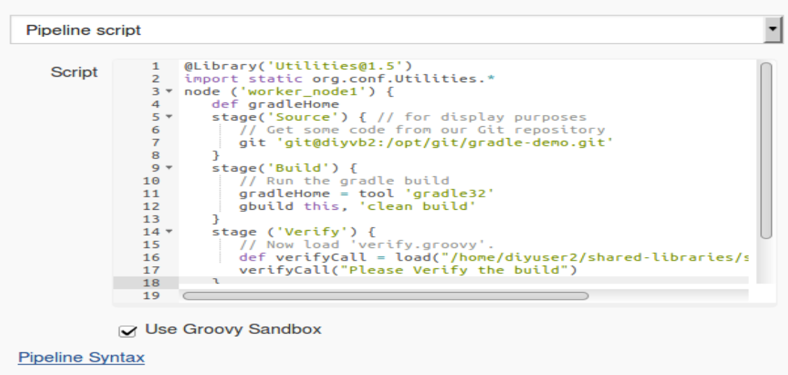

3. **Save** your changes and **Build Now**. You will now have a new stage **Verify** that shows up in the stage output view.

When the build reaches this stage, if you hover over the box in the **Verify** section, you’ll see the pop-up for you to tell it to **Proceed** or **Abort**.

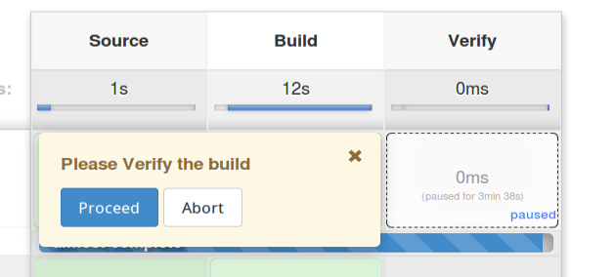

4. As well, if you look at the console output, you’ll see the process waiting for you to tell it to **proceed** or **abort** ( via clicking on one of the links).

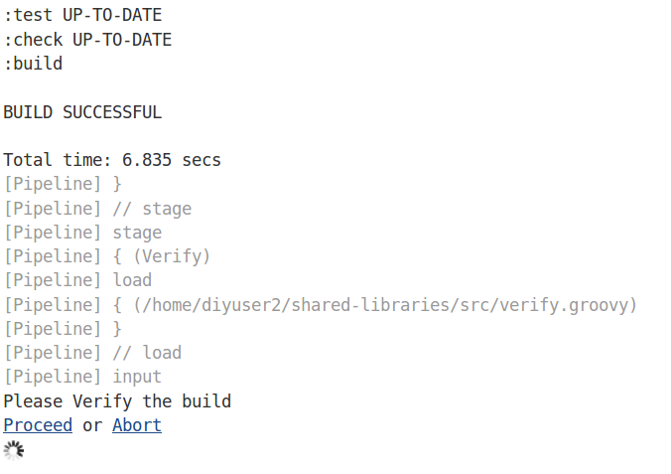

5. Go ahead and click the button or link to **Abort** the build. Note the failed status in the **Stage View**.

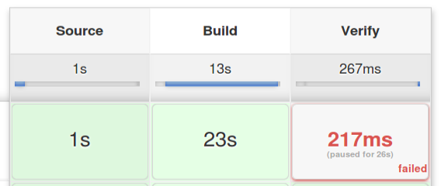

6. Let’s add a timeout to make sure the build doesn’t go on forever. To figure out the exact syntax, we’ll use the **Snippet Generator** tool. Click on the **Configure** button for the job, then scroll to the bottom and click on the **Pipeline Syntax** link.



7. You’ll now be in the Snippet Generator page. Here you can select what you want to do and then have Jenkins generate the Groovy pipeline code for you. To get our timeout code, select the following values:

In the **Sample Step dropdown,** select **“timeout: Enforce time limit”**

For the **Timeout** value, enter **5,**

For the **Unit value,** select **SECONDS**

8. Click on the **Generate Pipeline Script** button to see the resulting code.

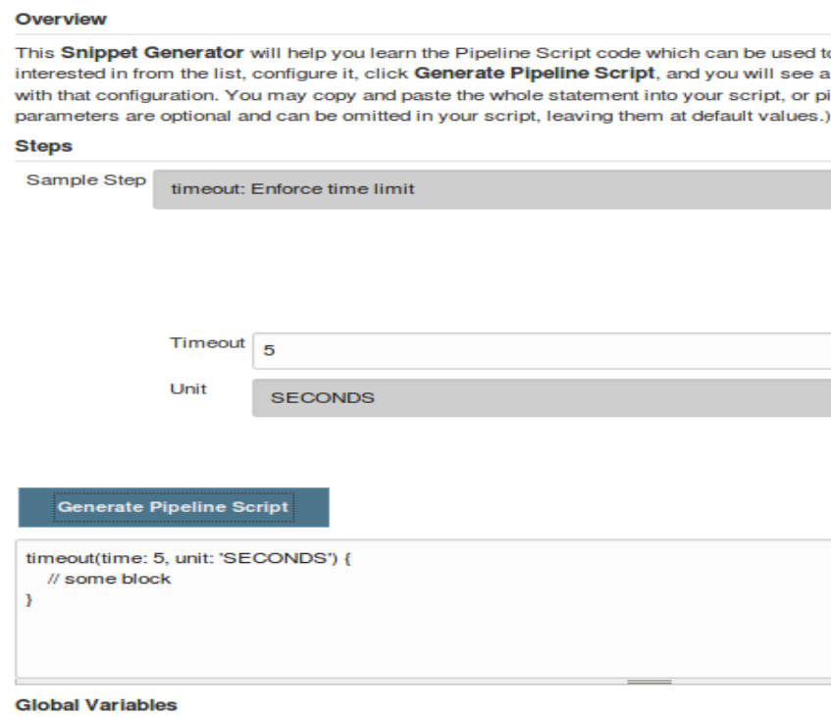

9. Copy and paste the **timeout** block lines around the verifyCall invocation in your pipeline script. You can use **Back->Configure** to get back to the script page.

**timeout(time: 5, unit: 'SECONDS') {**

verifyCall("Please Verify the build")

**}**

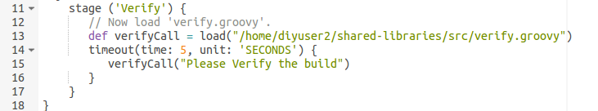

10. **Save** your changes and **Build Now**. Let the job run to see the timeout pass and the job fail.

**=============================================================================================**

**END OF LAB**

**=============================================================================================**

**Lab 5 - Using global functions and exception handling**

**Purpose: In this lab, we’ll see how to reference global functions and one way to handle exception processing**

1. For shared libraries, we can also define global functions under the “**vars**” subdirectory of our shared library repository. For use in this workshop, we have a function named “**mailUser**” defined in **~/shared-libraries/vars/mailUser.groovy**. The code in this function is:

def call(user, result) {

// Add mail message from snippet generator here

mail bcc: '', body: "The current build\'s result is ${result}.", cc: '', from: '', replyTo: '', subject: 'Build Status’"

}

2. As suggested by the comment, the basic text for the body of the function came from the **Snippet Generator**. As an optional exercise, you can go to the Snippet Generator (**see Lab 4**) and plug in the parts to create the basic “**mail**” line here. (We have changed some quoting and variables.)

3. In our pipeline script, we’ll add a **“Notify” stage** to send a basic message when the build is done. (Jenkins is already configured globally to be able to send email.) Add the following stage at the end of your pipeline script **after** the **Verify** **stage**, but **before** the ending bracket for the node definition. (Substitute in whatever email address is appropriate.)

} // end verify stage

**stage ('Notify') {**

**mailUser(<email address in single quotes>,"Finished")**

**}**

} // end node (already in pipeline)

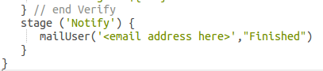

4. **Save** and **Build Now**. Try it with selecting **Proceed** and also with selecting **Abort** or letting the timeout happen. (Note: It may be easier to set the timeout value to 10 seconds instead of 5 to give you time to find and click Proceed.)

5. Notice that unless we select **Proceed**, the **Notify** stage is never reached. We want to be able to send the notification no matter what. How do we do this? We can handle this by adding a **try/catch** block around the other stages to catch the error and still allow the **Notify** stage to proceed.

6. Add the “**try {**“ line after the node definition and the “**catch**” block after the “**Verify**” stage (and before the **“Notify”**stage) as shown below.

node ('worker_node1') {

**try {**

stage('Source') { // for display purposes

…

verifyCall("Please Verify the build")

} // end timeout

} // end verify

**} // end try**

**catch (err) {**

**echo "Caught: ${err}"**

**}**

stage ('Notify')

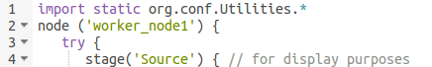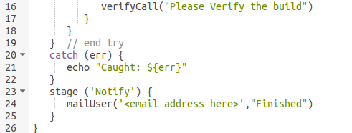

7. **Save** and **Build Now**. Let the process timeout and note that the mail is now sent regardless.

**=============================================================================================**

**END OF LAB**

**=============================================================================================**

**Lab 6 - Multibranch projects**

**Purpose: In this lab, we’ll see how to setup a multibranch pipeline project**

1. For this lab, we want to add some tests to our pipeline. The tests are in the “**test**” branch of our repository, so we will need to access them there. As well, we’d like Jenkins to automatically setup a project for our test branch.

2. To get Jenkins to recognize the branch in our project, we need to have a **Jenkinsfile** - similar to a build script - as a marker in the branch. Our cloned copy of our project - at **~/gradle-demo** already has one.

3. To see it, in a terminal cd to the **~/gradle-demo** project and **checkout** the **test** branch. Then cat the file.

**cd ~/gradle-demo**

**git checkout test**

**cat Jenkinsfile**

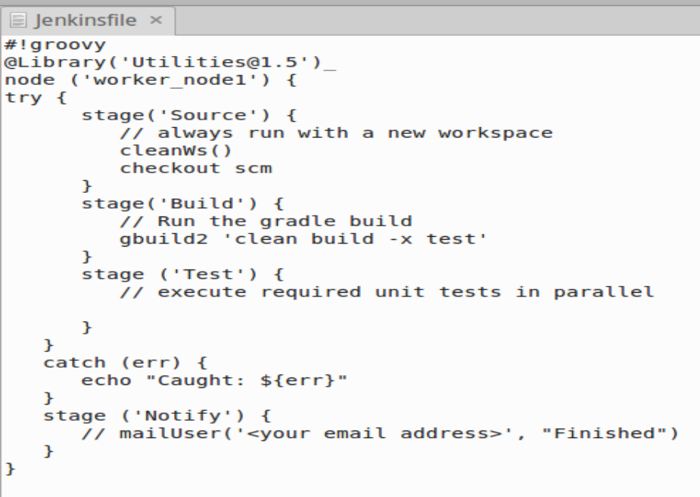

4. This file has a couple of changes that we need to talk through.

i. Notice the **#!groovy** declaration at the top. This is a best practice for Jenkinsfiles since they don’t have the .groovy extension to denote them as being groovy code.

ii. Then we have our **@Library** annotation to load our shared library. It is followed by the “**_**” character instead of an **import** statement. The reason for this is that we have switched from using the **gbuild** routine defined in a package in **org.conf.Utilities** to a global variable (function) named gbuild2. Like the mailUser function we used in the last lab, this is defined in the vars subdirectory - specifically in in **~/shared-libraries/vars/gbuild2.groovy**. So we don’t need the import any longer. We have the “**_**” character there because it is required to have something after an annotation **(@Library**).

iii. We’ve also changed our build step to use the call to **gbuild2** instead of **gbuild**.

The code for the **gbuild2** function is:

**def call(args) {**

**sh "${tool 'gradle32'}/bin/gradle ${args}"**

**}**

This code is simpler than the **gbuild** code. Since global variables/functions already have the script context, we don’t have to pass in the “script” object as we did for **gbuild.** Also, this is more portable between scripted and declarative pipelines. (More on that to come.)

iv. Notice that this file has a different way of specifying how to get the source. It simply says **checkout scm**. This is a shortcut, available because, since this is a multibranch project, Jenkins already knows the project and branch by virtue of the Jenkinsfile being in source control.

v. Finally, notice the line “**cleanWs()**”. This is telling Jenkins to wipe out (cleanup) the workspace before beginning the operation. This is specific to the node. The function is available due to the “Workspace Cleanup” plugin being installed. (Note: There is also a deleteDir() function to delete a directory.)

5. OPTIONAL. Currently the call to **mailUser** is commented out. If you want, you can edit the file (**gedit Jenkinsfile**), uncomment the line (remove the leading **//**), and replace **<your email address>** with a valid email address (and change the “**Finished**” message if you want). If you do this, then **save** the file and commit and push the updated file back into the repository.

**$ git add Jenkinsfile**

**$ git commit -m “updated email address”**

**$ git push origin test**

6. Now, we want Jenkins to automatically setup a project for this branch. From the dashboard, click on **New Item**. Give it a name of “**demo-all**” and select “**Multibranch Pipeline**” for the type. Then select **OK**.



7. On the **Configuration** page, in the **Branch Sources** section, click on the “**Add source**” button. Select **Git** from the dropdown and enter our repository location (**git@diyvb2:/opt/git/gradle-demo**) for the **Project Repository** section. You can leave the rest of the Branch Sources section as is. Also, make sure that the **Build Configuration Mode** is set to “**By Jenkinsfile**”.

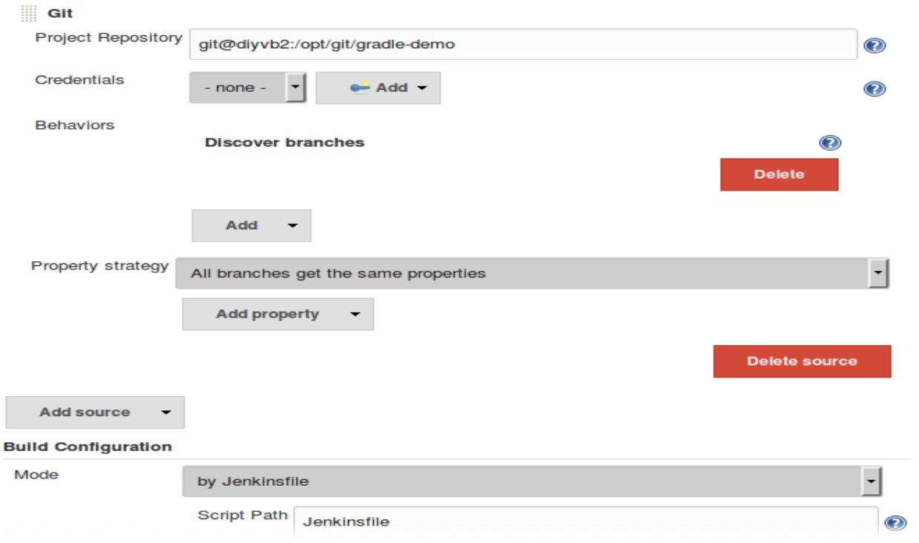

7. Scroll down to the bottom of the page. Notice there is a **Pipeline Libraries** section there. Since we have already defined the **Global Shared Libraries**, we don’t need to add anything here.

8. Now **Save** your changes. Jenkins now runs a **branch indexing** function looking for a **Jenkinsfile** in branches of the projects. Where it finds one, it can setup a build for it. Notice the log output identifying the master and test branches and the Jenkinsfile in the test branch.

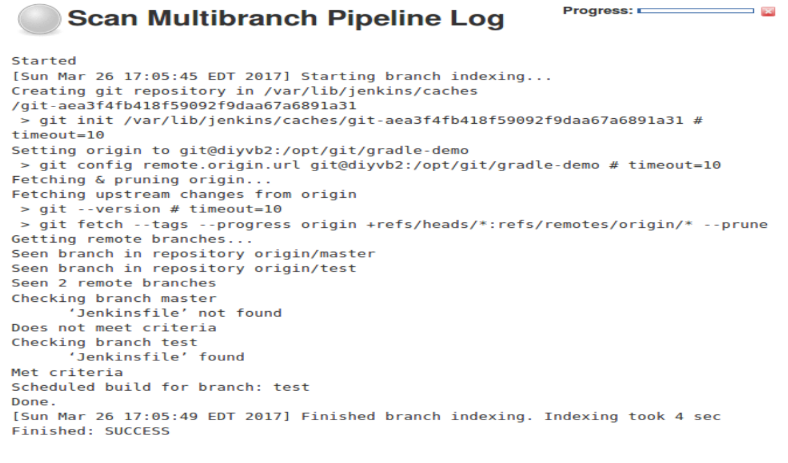

9. Click on the **Up** link in the top left, then go back into **demo-all** and notice that Jenkins has created a new job for the **test** branch and run it.

**=============================================================================================**

**END OF LAB**

**=============================================================================================**

**Lab 7 - Running in parallel and across multiple nodes**

**Purpose: In this lab, we’ll see how to add code to a script to do parallel processing and run across multiple nodes.**

1. Now we want to add the missing code for the **Test stage**. We have two tests in our Gradle project: **TestExample1.test** and **TestExample2.test**. To run either of these independently, we can use the Gradle invocation **-D test.single=<Test Name> test**.

2. For a simple demonstration of parallel execution, we’ll run each of these tests on a separate node. Since we earlier defined the **gbuild2** function as running “**gradle**”, we can reuse it here to call each test. We’ll wrap each call to **gradle** (via the **gbuild2** function) in a different node. So our initial pass at a parallel block might look like this.

**parallel (**

**worker2: { node ('worker_node2'){**

**// always run with a new workspace**

**cleanWs()**

**gbuild2 '-D test.single=TestExample1 test'**

**}},**

**worker3: { node ('worker_node3'){**

**// always run with a new workspace**

**cleanWs()**

**gbuild2 '-D test.single=TestExample2 test'**

**}},**

**)**

3. Go ahead and copy and paste this code in for the test stage in your **Jenkinsfile** in the **test** branch of the **gradle-demo** project. In a terminal session:

**gedit ~/gradle-demo/Jenkinsfile** (paste the code after the “// execute required unit tests…” line)

After adding the code in the editor, your file should look like the one below ( plus your email address if you changed that in the optional step in the previous lab ).

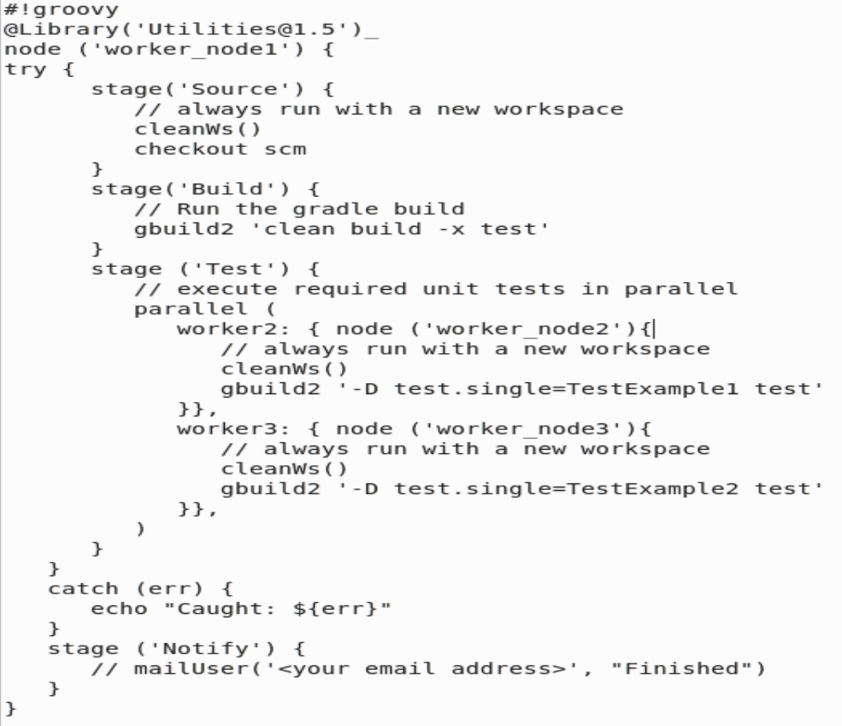

4. **Save** your changes, **stage**, **commit** and **push** the file.

**<Save changes to Jenkinsfile and quit the editor>**

**git add Jenkinsfile**

**git commit -m “updated for testing”**

**git push origin test**

5. Go back and re-run the **branch indexing** for **demo-all** again.

Click back to “**demo-all**”.

Select the “**Scan Multibranch Pipeline Now**” left menu item.

6. Now switch back to the “**test**” project under “**demo-all**”. It should have run again (if not, select “**Build Now**”). Within the **Stage View**, you should see that the **Test** stage failed. Let’s figure out why.

Open up the **Console Log** output for the latest run. Scroll down to find the section where the output for the “**Test**” stage starts. Further down find the lines for “**not found in root project**” when **worker2** and **worker3** were trying to run the tests. Why is this?

…

**[Pipeline] // stage**

**[Pipeline] stage**

**[Pipeline] { (Test)**

**[Pipeline] parallel**

**[Pipeline] [worker2] { (Branch: worker2)**

**[Pipeline] [worker3] { (Branch: worker3)**

**[Pipeline] [worker2] node**

**[worker2] Running on worker_node2 in /home/jenkins2/worker_node2/workspace/demo-all_test-ZQC7KCTZRKI2O5V23U5SXILJOWC6TUBFMWH2SZ3ND747GW7SHEKQ**

**[Pipeline] [worker3] node**

**[worker3] Running on worker_node3 in /home/jenkins2/worker_node3/workspace/demo-all_test-ZQC7KCTZRKI2O5V23U5SXILJOWC6TUBFMWH2SZ3ND747GW7SHEKQ**

**…**

**[worker2]**

**[worker2] FAILURE: Build failed with an exception.**

**[worker2]**

**[worker2] * What went wrong:**

**[worker2] Task 'test' not found in root project 'demo-all_test-ZQC7KCTZRKI2O5V23U5SXILJOWC6TUBFMWH2SZ3ND747GW7SHEKQ'.**

**[worker2]**

**[worker2] * Try:**

**[worker2] Run gradle tasks to get a list of available tasks. Run with --stacktrace option to get the stack trace. Run with --info or --debug option to get more log output.**

**[worker2]**

**[worker2] BUILD FAILED**

**[worker2]**

**[worker2] Total time: 3.862 secs**

**[worker3]**

**[worker3] FAILURE: Build failed with an exception.**

**[worker3]**

**[worker3] * What went wrong:**

**[worker3] Task 'test' not found in root project 'demo-all_test-ZQC7KCTZRKI2O5V23U5SXILJOWC6TUBFMWH2SZ3ND747GW7SHEKQ'.**

**[worker3]**

**[worker3] * Try:**

**[worker3] Run gradle tasks to get a list of available tasks. Run with --stacktrace option to get the stack trace. Run with --info or --debug option to get more log output.**

**[worker3]**

**[worker3] BUILD FAILED**

**[worker3] …**

7. The reason we can’t run the **Test** stage on **worker2** (**worker-node2**) is because the cloned content is only on **worker-node1** (where the original node was running and where the source management clone was done). Fortunately, Jenkins provides a way to save and share content between nodes with the **stash** command. To begin using this, we first need to **stash** the **src** directory (where the test content is) and the **build.gradle** file from the worker-node1 node.

8. Edit the **Jenkinsfile** again. Add a line after the **checkout scm** command like this:

**stash name: 'test-sources', includes: 'build.gradle,src/test/'**

9. For the nodes where we are running the parallel tests, we use the corresponding unstash command to recover the files needed from the original node. Add lines to do the “un-stashing” **after** the step call to clean up the workspace in each **node** specification in the **parallel** block. (See listing below.)

**unstash 'test-sources'**

When you have made the changes, your file should look like this (with the **new lines in bold**).

#!groovy

@Library('Utilities@1.5')_

node ('worker_node1') {

try {

stage('Source') {

// always run with a new workspace

cleanupWs()

checkout scm

**stash name: 'test-sources', includes: 'build.gradle,src/test/'**

}

stage('Build') {

// Run the gradle build

gbuild2 'clean build -x test'

}

stage ('Test') {

// execute required unit tests in parallel

parallel (

worker2: { node ('worker_node2'){

// always run with a new workspace

cleanupWs()

**unstash 'test-sources'**

gbuild2 '-D test.single=TestExample1 test'

}},

worker3: { node ('worker_node3'){

// always run with a new workspace

cleanupWs()

**unstash 'test-sources'**

gbuild2 '-D test.single=TestExample2 test'

}},

)

}

}

catch (err) {

echo "Caught: ${err}"

}

stage ('Notify') {

// mailUser('<your email address>', "Finished")

}

}

9. **Save** your changes to the file, **stage, commit,** and **push** it.

**<Save changes to Jenkinsfile>**

**git add Jenkinsfile**

**git commit -m “updated for stashing”**

**git push**

10. Now, go back and **Build Now** the **test** project. In the **Console Output**, you should be able to see the two parallel tests being executed. Eventually one will succeed and and one will fail (with a legitimate test failure).

**…**

**[Pipeline] }**

**[Pipeline] // stage**

**[Pipeline] stage**

**[Pipeline] { (Test)**

**[Pipeline] parallel**

**[Pipeline] [worker2] { (Branch: worker2)**

**[Pipeline] [worker3] { (Branch: worker3)**

**[Pipeline] [worker2] node**

**[worker2] Running on worker_node2 in /home/jenkins2/worker_node2/workspace/demo-all_test-ZQC7KCTZRKI2O5V23U5SXILJOWC6TUBFMWH2SZ3ND747GW7SHEKQ**

**[Pipeline] [worker3] node**

**[Pipeline] [worker2] {**

**[worker3] Running on worker_node3 in /home/jenkins2/worker_node3/workspace/demo-all_test-ZQC7KCTZRKI2O5V23U5SXILJOWC6TUBFMWH2SZ3ND747GW7SHEKQ**

**…**

**[worker2]**

**[worker2]**

**[worker2] BUILD SUCCESSFUL**

**[worker2]**

**[worker2] Total time: 26.408 secs**

**[Pipeline] [worker2] }**

**[Pipeline] [worker2] // node**

**[Pipeline] [worker2] }**

**[worker3] :compileJava UP-TO-DATE**

**[worker3] :processResources UP-TO-DATE**

**[worker3] :classes UP-TO-DATE**

**[worker3] :compileTestJava**

**[worker3] :processTestResources UP-TO-DATE**

**[worker3] :testClasses**

**[worker3] :test**

**[worker3]**

**[worker3]**

**[worker3] TestExample2 > example2 FAILED**

**[worker3] org.junit.ComparisonFailure at TestExample2.java:10**

**[worker3]**

**[worker3] 1 test completed, 1 failed**

**[worker3] :test FAILED**

**…**

**[worker3]**

**[worker3] FAILURE: Build failed with an exception.**

**[worker3]**

**[worker3] * What went wrong:**

**[worker3] Execution failed for task ':test'.**

**[worker3] > There were failing tests.**

**=============================================================================================**

**END OF LAB**

**=============================================================================================**

**Lab 8 - Creating a Declarative Pipeline**

**Purpose: In this lab, we’ll see how to convert a scripted pipeline to a declarative pipeline.**

1. To start to get a handle on how declarative pipelines are structured, we’re going to convert the scripted pipeline in the **Jenkinsfile** from Lab 7 into a declarative pipeline. To begin the process, we’ll create a new branch to work in. (This will also be incorporated into our multibranch pipeline later.)

Switch back to the terminal session. You should be in the **/home/diyuser2/gradle-demo** directory. Now we want to create a new branch in our project so we can separate the declarative Jenkinsfile from the scripted one in branch **test.**

Run the following command to create the new branch and switch to it.

**$ git checkout -b decl test**

2. Now we’ll edit the **Jenkinsfile** in this branch and convert it from a scripted pipeline to a declarative pipeline. Open the file in an editor.

**$ gedit Jenkinsfile**

3. We need to first make some changes in the beginning section of the pipeline script. We will keep the **#!groovy** as an indicator that this is a Jenkins script. But we need to wrap everything in our pipeline in a **pipeline** closure. Then instead of the **node** definition here, we need an **agent** specification. We can also remove the **Library** block as we’ll do this in a different way in the declarative model.

Change these lines:

**@Library('Utilities@1.5') _**

**node ('worker_node1') {**

to

**pipeline {**

**agent{ label 'worker_node1'}**

4. Next, let’s add the load of our shared-library via the libraries directive. Put this directive under the agent declaration from step 3 (under the **agent {** line and before the **try {** line).

**libraries {**

**lib('Utilities@1.5')**

**}**

5. In a declarative pipeline, our collection of stages need to be wrapped in a **stages** closure. In our scripted pipeline, because we are using the Groovy **try-catch** mechanism to wrap all the stages, we can just replace that with the **stages** closure.

Change the

**try {**

statement to be

**stages {**

The top part of your Jenkinsfile should now look like this (changed lines in bold):

#!groovy

**pipeline {**

**agent{ label 'worker_node1'}**

**libraries {**

**lib('Utilities@1.5')**

**}**

**stages {**

stage('Source') {

6. In the declarative structure, each set of individual steps in a stage needs to be enclosed in a **steps** closure. Within each individual **stage** section (except for the Notify one), add a **steps** closure around the statements. Since we’re not adding any other directives in the stages, you can just add “**steps {**“ after each “**stage (…) {**“ line and a closing bracket “**}**” at the end of each stage.

For example, after the changes, our first stage for **Source** would look like this (indention updated for clarity).

stage('Source') {

**steps {**

cleanWs()

checkout scm

stash name: 'test-sources', includes: 'build.gradle,src/test/'

**}**

}

Make sure to add the **steps {}** closure in the **Build** and **Test** stages as well!

7. Next, let’s change the failing test in the ‘Test’ stage to one that will pass so we can see a successful run of the declarative pipeline. Change the line for

gbuild2 '-D test.single=TestExample**2** test'

to

gbuild2 '-D test.single=TestExample**3** test'

8. Lastly, in declarative syntax, we have a **post** section that we can use to emulate the **post-build actions** of freestyle jobs. We’re going to replace the scripted **catch** section with a declarative **post** section.

In the Jenkinsfile, erase/delete the **catch** and **notify** blocks from the pipeline. (Note there should still be a closing bracket after this from the original node closure we had. Leave that ending bracket.) The lines below are the ones to remove.

**catch (err) {**

**echo "Caught: ${err}"**

**}**

**stage ('Notify') {**

**// mailUser('<your email address>', "Finished")**

**}**

9. Now, add the section below at the place in the file where you just deleted the lines in the last step. Substitute in an email address where you can receive email for the “<your email address>” parts. Add these lines before the final closing bracket of the **pipeline** block.

**post {**

**always {**

**echo "Build stage complete"**

**}**

**failure {**

**echo "Build failed"**

**mail body: 'build failed', subject: 'Build failed!', to: '**<your email address>**'**

**}**

**success {**

**echo "Build succeeded"**

**mail body: 'build succeeded', subject: 'Build Succeeded', to: '**<your email address>**'**

**}**

**}**

**IMPORTANT**: Don’t forget to put in a valid email address in the lines starting with “**mail”**!

9. After all of these changes, your pipeline in the Jenkinsfile should look like the one below, except that you should have your email address inserted for “<your email address>”. Verify and then **save** the file as **Jenkinsfile** in the directory.

#!groovy

pipeline {

agent{ label 'worker_node1'}

libraries {

lib('Utilities@1.5')

}

stages {

stage('Source') {

steps {

cleanWs()

checkout scm

stash name: 'test-sources', includes: 'build.gradle,src/test/'

}

}

stage('Build') {

// Run the gradle build

steps {

gbuild2 'clean build -x test'

}

}

stage ('Test') {

// execute required unit tests in parallel

steps {

parallel (

worker2: { node ('worker_node2'){

// always run with a new workspace

cleanWs()

unstash 'test-sources'

gbuild2 '-D test.single=TestExample1 test'

}},

worker3: { node ('worker_node3'){

// always run with a new workspace

cleanWs()

unstash 'test-sources'

gbuild2 '-D test.single=TestExample3 test'

}},

)

}

}

} // end stages

post {

always {

echo "Build stage complete"

}

failure{

echo "Build failed"

mail body: 'build failed', subject: 'Build failed!', to: '<your email address>'

}

success {

echo "Build succeeded"

mail body: 'build succeeded', subject: 'Build Succeeded', to: '<your email address>'

}

}

} // end pipeline

10. After saving the file, add, commit, and push the updated Jenkinsfile (in branch **decl**).

**$ git add Jenkinsfile**

**$ git commit -m “Add declarative Jenkinsfile”**

**$ git push origin decl**

11. We’ve now created a new branch in our **multibranch** setup. Now we want Jenkins to create a new project for it. Switch back to **Jenkins** and go into the **demo-all** project (if not already there).

Click on the “**Scan Multibranch Pipeline Now**” to generate a new job for the **decl** branch and run the script. It should succeed.

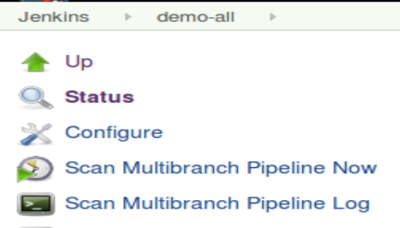



**=============================================================================================**

**END OF LAB**

**=============================================================================================**

**Lab 9 - Using Blue Ocean**

**Purpose: In this lab, we’ll see how to use Jenkin’s new Blue Ocean interface**

1. In Jenkins, go back to the dashboard (**localhost:8080**). Open the Blue Ocean interface either by going to **http://localhost:8080/blue** or by clicking the “**Open Blue Ocean**” menu item on the lefthand side of the page.

2. Once the main Blue Ocean page finishes loading, you should be on the **Pipelines** page. You can think of this page as being like the **dashboard** in the traditional interface.

It allows you to see a list of defined projects and their health (the weather icon) and success/failure status.

The **PR** column is for Pull Requests if we have any related to a project.

The star on the end is a way to add a favorite for quick reference at the top of the page. (Note: This only works if Jenkins can determine what the “default” item in the project should be. For project types with subitems, it may not be able to “favorite” them.) The star is a toggle. Click on some of the stars to see how the favorite action works. You can click on them again to remove something from the favorites area.

3. Since Blue Ocean is optimized for declarative pipelines, we’ll take a closer look at our pipeline for the **decl** branch through it.

Click on the **demo-all** project. This takes you to the **Activity** page for **demo-all**. Here, you can see the set of runs related to this project. You can think of this like the page in the traditional interface that shows the runs for a project.

4. Now, in the row above the list, click on the **Branches** item. As expected, this shows the list of branches associated with this multi-branch pipeline. (This option (clicking on Branches ) only works for multibranch projects. )

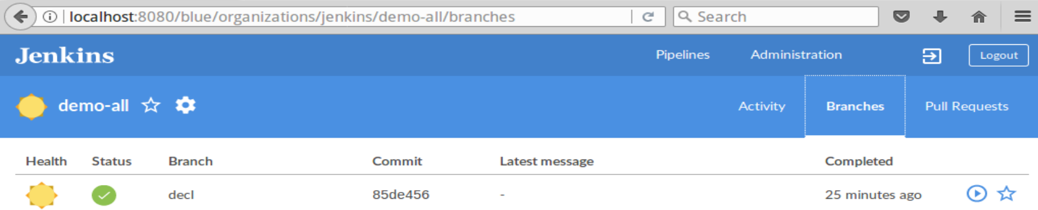

5. Find the row for our decl branch. Near the end of the row is a *circle with an arrow* in it. If you hover over that, you’ll see that it says “**Run**”. Click on that symbol.

A small box should pop up in the lower left corner with an “**OPEN**” link. Click on that (or click anywhere in the row for **decl**).

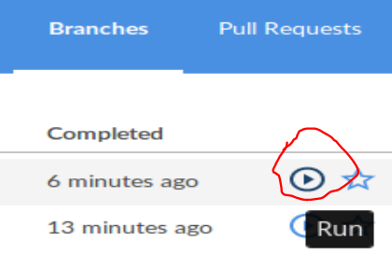 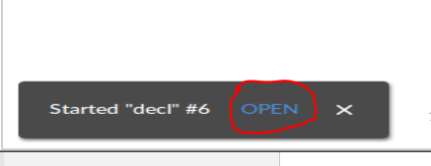

That will take you to the screen showing the pipeline executing. It will look something like the picture below.

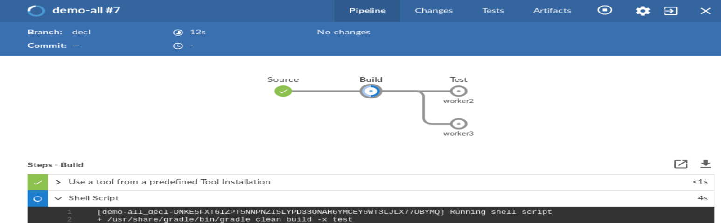

6. Notice the circle shapes representing each stage as it progresses, along with the running log at the bottom. When the pipeline completes the run, look at the logs for one of the stages. To do this, click on one of the circles representing a stage in the figure, and then click on the one of the steps listed in the bottom half of the page.

For example, click on the circle at the end labeled **worker2**. This is one of the parallel parts of our **Test** stage. Now, click on the **Shell Script** item in the bottom section (under **Steps - worker2**). Notice that Jenkins displays the part of the log for this part of the pipeline Clicking on Shell Script again collapses the log information.

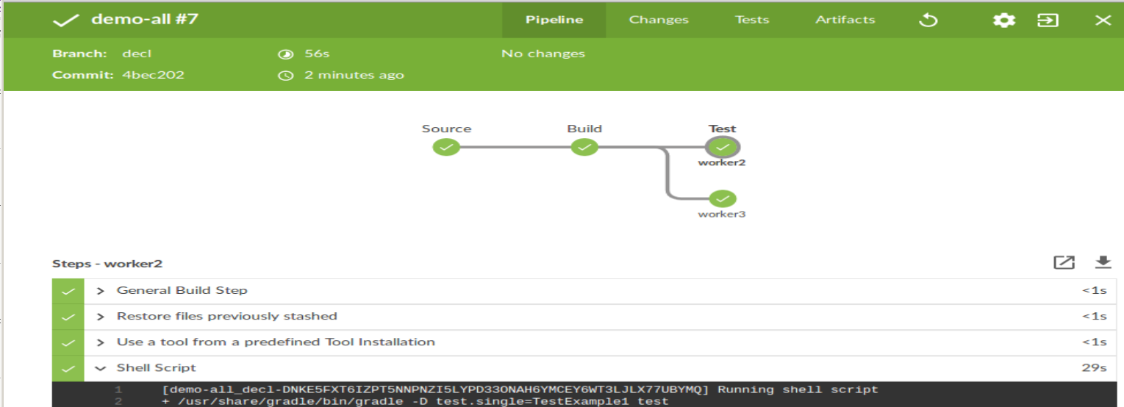

7. Find the icon that looks like a gear in the upper left section of the page. That opens up a browser tab that puts you into the traditional **Configure** page for the project. Click on the Gear icon now to try this out.

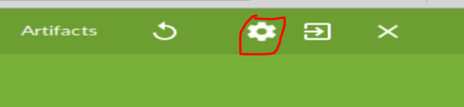

Note that this opens the configure page in a new tab.

8. Switch back to the Blue Ocean tab for the decl job. Exit the log of this run by clicking on the X in the upper right corner. Then click Pipelines in the top row to get back to the Blue Ocean dashboard.

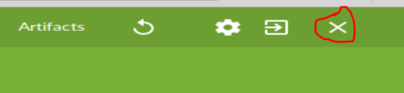

9. Let’s look at a couple of other features in Blue Ocean. The **Administration** link is like the **Manage Jenkins** link in the classic interface. Click on it to go to the **Manage Jenkins** page.

Click on the **Adminstration** link.

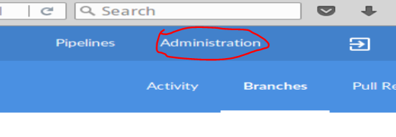

Then click on the back arrow in the browser to get back to the Blue Ocean interface.

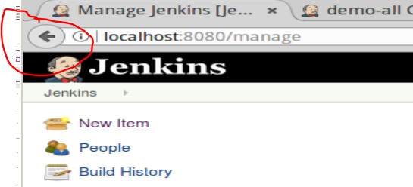

9. You should be back on the **Pipelines** page (http://localhost:8080/blue/pipelines). (If not, click on the **Pipelines** link at the top of the page.) Notice that there is a button here to create a **New Pipeline**. Let’s see how that works. Click on the button.

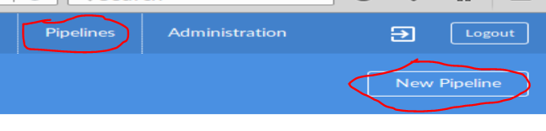

10. This page is essentially the “**New Item**” interface for a project stored in Git. The idea is you would create a **Jenkinsfile** in a project stored in Git and that becomes the basis for your new pipeline or you can create one through the interface’s Pipeline Editor. You are first asked if your project is stored in Git, Github, BitBucket (or their enterprise versions). We will just reference one on our local system to see how this is done. Select the **Git** option.

11. For the **Repository URL**, we’ll just enter the location of the same Git repository we’ve been using.

Enter **git@diyvb2:/opt/git/gradle-demo** in the **Repository URL** field.

12. Because of the URL, Jenkins will prompt you to “register” an SSH key (as shown below). This key needs to be added as an authorized key in the authorized_key file under /home/git/.ssh.

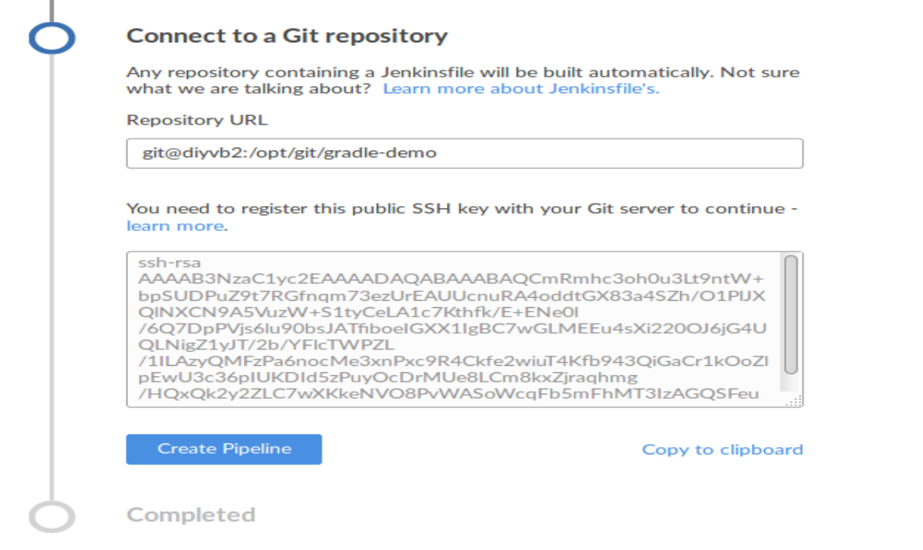

To get this added to the file, do the following:

Click on the “**Copy to clipboard**” link.

In a terminal, edit the file

**sudo gedit /home/git/.ssh/authorized_keys**

When the file opens up in the editor, paste the copied key into the file.

Save the file and exit the editor.

13. Click on the **Create Pipeline** button to create the new pipeline.

14. Jenkins will setup a pipeline for the projects/branches that it finds with a **Jenkinsfile** in it. Then it will start a build for all those projects/branches (eventually).

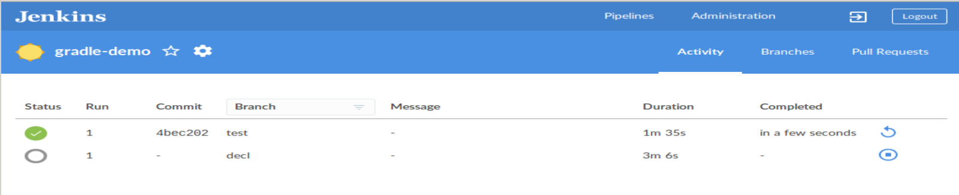

15. Click on the symbol with the arrow in the square (next to **Logout**) to go back to the “classic” interface. You’ll see the classic interface of the pipeline that was created.

 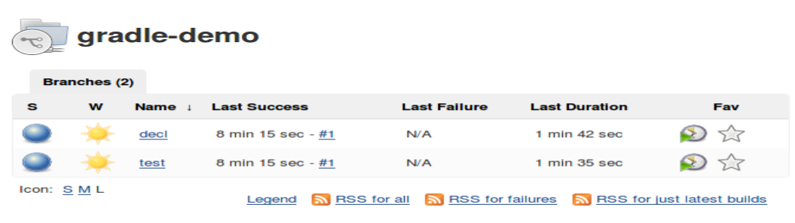

**=============================================================================================**

**END OF LAB**

**=============================================================================================**

**Lab 10 - Integrating Docker**

**Purpose: In this lab, we’ll see how to use Docker in our pipeline. For simplicity, we’ll start with a copy of our declarative Jenkinsfile from the last lab and just update it to use Docker.**

1. In this lab, we’ll work with Docker images in two ways. First, we’ll create a custom Docker image containing Gradle to use in our Gradle operations. We’ll create this image using an **agent** specification that takes a **Dockerfile**. We have a **Dockerfile** already on disk. Take a look at it with the following command in a terminal session.

**$ cat /home/diyuser2/docker/Dockerfile**

2. For some parts of the pipeline, we’ll use a ready-made version of this image already existing on your disk. To see it, in a terminal session, run this command:

**$ docker images**

The image named **gradle** with tag **3.4.1** is the one that contains Gradle for us to use.

3. To start working on this version separately, we need to create a separate branch in our **demo-all** project with its own copy of the **Jenkinsfile**. To do this create a new branch based off branch decl in our gradle-demo project. Make sure you are in the **gradle-demo** project directory in a terminal session. Then create the new branch and edit the **Jenkinsfile**.

**$ git checkout -b docker decl**

**$ gedit Jenkinsfile**

4. In the **Jenkinsfile**, we need to make a couple of changes for using Docker. First, since we are going to be using Docker images instead of library routines to run Gradle, we can remove the **libraries** directive and information. Delete the lines below from your **Jenkinsfile**.

**libraries {**

**lib('Utilities@1.5')**

**}**

5. Now, in the **Build** stage, we’ll create a new Docker agent to use for the build. This **agent** will be created using the Dockerfile we looked at earlier. Add the lines shown in bold below to tell Jenkins to construct the Docker container built from the Dockerfile. Note that they are after the **Build** stage closure - but before the **steps** closure.

stage('Build') {

**agent {**

**dockerfile {**

**dir '/home/diyuser2/docker'**

**}**

**}**

steps {

// Run the gradle build

6. This will do several things for us. It will create an image with Gradle in it - based on the statements in the Dockerfile. Then it will start a Docker container that runs the image. Next, it will map our workspace into the container (assuming it has access). And, then it will run any steps starting with “**sh**” (shell) inside the context of the container.

7. Since we will be running our Gradle build command inside the Docker agent’s container and not through the library anymore, we need to change our build command. In the **Build** stage, in the **steps** block, change the line

**gbuild2 'clean build -x test'**

to be

**sh 'gradle clean build -x test'**

8. Now, in the **Test** stage, we will update the existing steps to just use a predefined instance of our image. As a reminder, that image is named “**gradle**” with a Docker tag of “**3.4.1**” (indicating the version). So we can refer to the image by the identifier “**gradle:3.4.1**”.

Within the **parallel** step in the **Test** stage, the mappings for **worker2** and **worker3** already have **nodes** specified. We cannot create multiple agents in a step, so we’ll use another approach. We’ll wrap our build command in each parallel part in a “**withDockerContainer**” block. **withDockerContainer** takes the name of an image to run as an argument. We will use the predefined **gradle:3.4.1** image for this.

Add a **withDockerContainer** closure around each build command in the **Test** stage. This means add the lines in bold below.

worker2: { node ('worker_node2') {

// always run with a new workspace

step([$class: 'WsCleanup'])

unstash 'test-sources'

**withDockerContainer('gradle:3.4.1') {**

gbuild2 ’ -D test.single=TestExample1 test'

**}**

}} ,

worker3: { node ('worker_node3'){

// always run with a new workspace

step([$class: 'WsCleanup'])

unstash 'test-sources'

**withDockerContainer('gradle:3.4.1') {**

gbuild2 ‘-D test.single=TestExample3 test'

}

}},

9. Also, we’ll need to change the gbuild2 commands to the same kind of sh commands we used above. This is because we removed the library reference that had the gbuild2 command, and are replacing that with Gradle running in the Docker container. Change the start of the build lines in the Test stage from:

**gbuild2 ‘-D test.single**

to

**sh 'gradle -D test.single**

10. After these changes, the main part of your **Test** stage should look like this (changed or added lines are in bold):

worker2: { node ('worker_node2') {

cleanupWs()

unstash 'test-sources'

**withDockerContainer('gradle:3.4.1') {**

**sh 'gradle -D test.single=TestExample1 test'**

**}**

}} ,

worker3: { node ('worker_node3'){

// always run with a new workspace

cleanupWs()

unstash 'test-sources'

**withDockerContainer('gradle:3.4.1') {**

**sh 'gradle -D test.single=TestExample3 test'**

**}**

}},

11. Save your Jenkinsfile.

12. Now add, commit, and push the updated Jenkinsfile (in branch docker).

**$ git add Jenkinsfile**

**$ git commit -am “Update to use Docker”**

**$ git push origin docker**

13. We’ve created a new branch in our multibranch setup. Now we want Jenkins to create a new project for it. Switch back to **Jenkins.** We can use the **gradle-demo** multibranch project that got created in our last lab through Blue Ocean. Switch to that project (if not already there).

Click on the “**Scan Multibranch Pipeline Now**” to generate a new job for the **docker** branch and run the script. It should succeed.

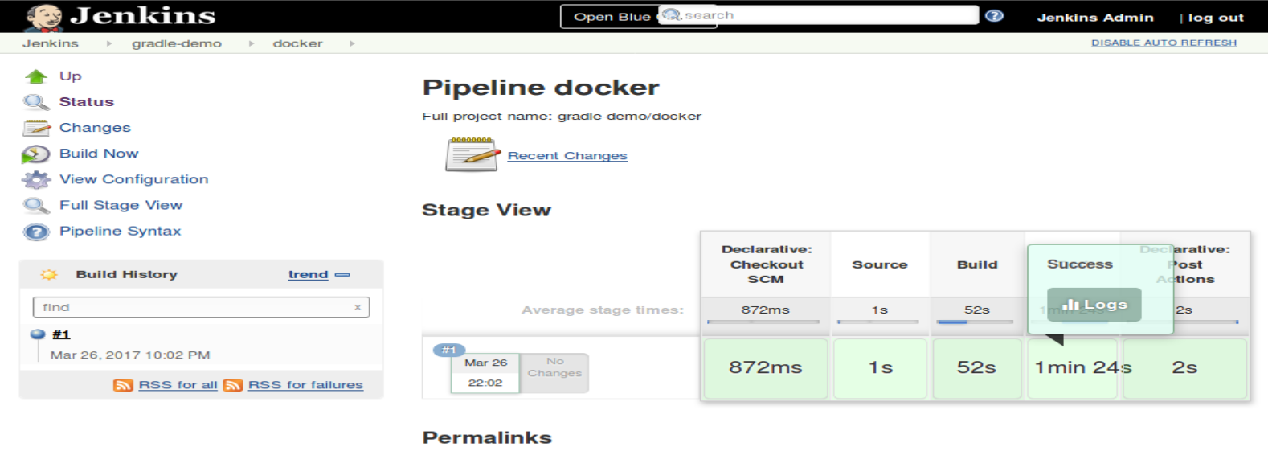

14. Take a look at the console output for the run to see the construction of the Docker image and use of Docker in the **Test** stage.

**=============================================================================================**

**END OF LAB**

**=============================================================================================**

**OPTIONAL Lab 11 - Including a Jenkinsfile back into a native Jenkins project**

**Purpose: In this optional lab, we’ll see how to take a Jenkinsfile and include it in a native Jenkins pipeline project. We’ll use the Docker project we just created in the previous lab as our example.**

1. In Jenkins, create a new project from the dashboard. (Switch back to the dashboard at http://localhost:8080 and click on the **New Item** menu item.) Select **Pipeline** for type of project. Name it whatever you like. Once you are on the configuration page, scroll down to the text entry block for the code.

2. On the **Pipeline** section of the page, you’ll see a field called **Definition**. This will have **Pipeline script** in it by default. At the end of that field is an arrow to select entries from a list. Click on that arrow and select **Pipeline script from SCM**.

3. You’ll now see a new field named **SCM**. Select **Git** from the list in that field.

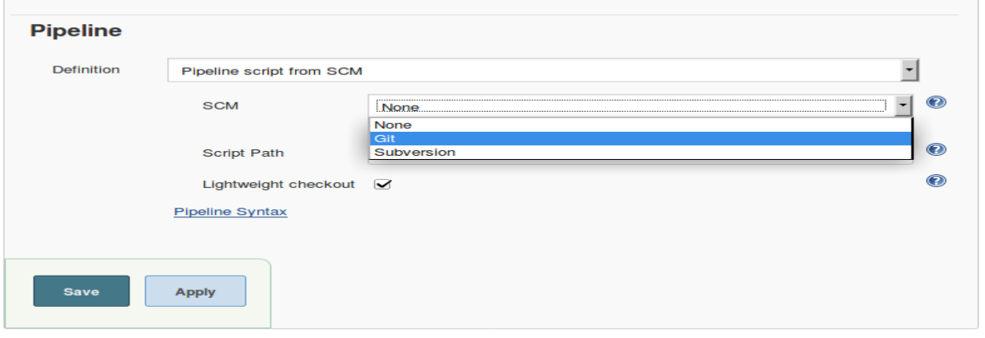

4. Once you select Git, additional fields will show up on the screen.

Fill in the **Repository URL** field with **git@diyvb2:/opt/git/gradle-demo.git**

Fill in the **Branches** field with **docker**

5. You can leave everything else as-is. Now **Save** the changes and select **Build Now** to build the pipeline.

**=============================================================================================**

**END OF LAB**

**=============================================================================================**